STANDING WAVES AND VSWR ANALYSIS
A Project Based Learning Report Submitted in partial fulfilment of the requirements for the award of the degree

of

Bachelor of Technology
in The Department of ECE
24EC2209 ELECTROMAGNETIC WAVES AND TRANSMISSION LINES
Submitted by
2410040008 - TALLA SUNNY
2410040009 – VARAGANTI PRAACHURYA
2410040010 - MORLA HEMANTH VENKATA SAI
2410040135 - KALLEPALLY AKHILA
Under the guidance of
Dr. Jithendra Sharma



Department of Electronics and Communication Engineering
Koneru Lakshmaiah Education Foundation, Aziz Nagar
Aziz Nagar – 500075
APRIL-2026

ABSTARCT

Standing waves and Voltage Standing Wave Ratio (VSWR) are fundamental concepts in transmission line theory, widely used in communication systems, microwave engineering, and antenna design. This project focuses on understanding the formation of standing waves due to impedance mismatch in transmission lines and analyzing their effect using VSWR measurements.

When a signal travels through a transmission line and encounters an impedance mismatch at the load, part of the signal is reflected back toward the source. The superposition of incident and reflected waves results in a standing wave pattern. These standing waves consist of nodes (minimum voltage) and antinodes (maximum voltage), which can be observed and measured.
The Voltage Standing Wave Ratio (VSWR) is a critical parameter used to quantify the efficiency of power transmission in a system. A VSWR value of 1 indicates perfect matching, while higher values indicate increasing levels of reflection and inefficiency. In this project, we study how VSWR varies with changes in load impedance and frequency.

The experiment involves setting up a transmission line system using a signal generator, slotted line apparatus, and detector. Measurements are taken to determine maximum and minimum voltages, from which VSWR is calculated. Graphical analysis is also performed to visualize standing wave patterns and understand the relationship between VSWR and reflection coefficient.
This study helps in understanding practical issues in communication systems such as signal loss, power efficiency, and impedance matching. The knowledge gained is essential for designing efficient RF and microwave systems.

- TABLE OF CONTENTS
- Abstract ...................................................... 2
- Introduction ................................................. 4
- Methodology ............................................... 5
3.1 Theoretical Background ............................ 5
3.2 Apparatus Required ................................ 5
3.3 Experimental Setup ................................. 6
3.4 Procedure ................................................. 6
3.5 Data Collection ........................................ 7
3.6 Analysis .................................................. 87
- Experiment (Explanation) ......................... 9
- Results and Discussion .......................... 8
5.1 Observations Table ................................. 7
5.2 Graphs .................................................. 8
5.3 Analysis of Results ................................. 8
- Conclusion ............................................. 11
- References ............................................ 11

STANDING WAVES AND VSWR ANALAYSIS

Introduction

In modern communication systems, efficient transmission of signals is essential for reliable performance. Transmission lines are used to carry signals from one point to another, especially at high frequencies. However, when there is a mismatch between the load impedance and the characteristic impedance of the transmission line, part of the signal gets reflected back toward the source.

This reflection leads to the formation of standing waves, which are characterized by alternating points of maximum and minimum voltage along the transmission line. These points are known as antinodes and nodes respectively. The presence of standing waves indicates inefficient power transfer and possible signal distortion.
The Voltage Standing Wave Ratio (VSWR) is a measure used to quantify this phenomenon. It is defined as the ratio of maximum voltage to minimum voltage in a standing wave pattern. A VSWR value close to 1 indicates minimal reflection and efficient transmission, whereas higher values indicate poor impedance matching.

Understanding standing waves and VSWR is crucial in fields such as antenna design, microwave engineering, and RF communication systems. This project aims to study the behavior of standing waves, calculate VSWR, and analyze how impedance mismatch affects signal transmission efficiency.

METHODOLOGY

Theoretical Background

Standing waves are formed in a transmission line when an incident wave traveling from the source toward the load is partially or completely reflected due to impedance mismatch. The superposition of the forward (incident) wave and the reflected wave creates a stationary pattern of voltage and current known as a standing wave.
In an ideal matched condition, the load impedance (ZL) is equal to the characteristic impedance (Z0) of the transmission line, resulting in no reflections. However, in practical scenarios, mismatches are common, leading to reflected waves.
The Voltage Standing Wave Ratio (VSWR) is used to quantify the extent of mismatch and is defined as:
VSWR = Vmax / Vmin
Where:
- Vmax = Maximum voltage (antinodes)
- Vmin = Minimum voltage (nodes)
The reflection coefficient (Γ) is given by:
Γ = (ZL − Z0) / (ZL + Z0)
The relationship between VSWR and reflection coefficient is:
VSWR = (1 + |Γ|) / (1 − |Γ|)
A VSWR value of:
- 1 indicates perfect matching
- >1 indicates mismatch
- ∞ indicates complete reflection

Apparatus Required
The following equipment is used to perform the experiment:
- Microwave signal generator
- Slotted line section
- Tunable probe detector
- VSWR meter
- Transmission line (coaxial/waveguide)
- Matched load
- Mismatched loads (variable impedance)
- Connecting cables and power supply

Experimental Setup
The experimental setup consists of a signal generator connected to a transmission line through appropriate connectors. The transmission line is terminated with a load impedance.
A slotted line section is introduced along the transmission line to allow measurement of voltage variations. A movable probe is inserted into the slot to detect the electric field (voltage) at different points along the line.
The detector is connected to a VSWR meter, which displays the relative voltage levels. By moving the probe along the line, positions of maximum and minimum voltages can be identified.

Procedure
- Setup Initialization
  - Connect the signal generator to the transmission line.
  - Attach the load at the end of the line.
  - Ensure all connections are tight and secure.
- Power ON
  - Switch on the signal generator and set a suitable frequency (microwave range).
  - Allow the system to stabilize.
- Probe Adjustment
  - Insert the probe into the slotted line carefully.
  - Move the probe along the line to detect voltage variations.
- Measurement of Voltages
  - Identify and record the positions where voltage is maximum (Vmax).
  - Identify and record positions where voltage is minimum (Vmin).
- Calculation of VSWR
  - Use the formula:
VSWR = Vmax / Vmin
- Repeat Measurements
  - Change load impedance.
  - Repeat the above steps for different loads.
- Wavelength Measurement
  - Measure distance between two consecutive minima.
  - Wavelength (λ) = 2 × distance between nodes.

Data Collection
The following data is recorded during the experiment:
- Maximum voltage (Vmax)
- Minimum voltage (Vmin)
- Position of nodes and antinodes
- Load impedance values
- Frequency of operation

Data Analysis
- Calculate VSWR for each observation.
- Determine reflection coefficient using VSWR formula.
- Plot graphs:
  - Voltage vs Distance
  - VSWR vs Load Impedance
  - VSWR vs Reflection Coefficient
- Analyse:
  - Effect of impedance mismatch
  - Variation in standing wave pattern
  - Efficiency of power transmission

Error Analysis
Possible sources of error include:
- Improper probe positioning
- Signal generator instability
- Connector losses
- Human reading errors
- External noise interference
These errors can slightly affect the accuracy of VSWR measurements.

- REALISTIC LAB OBSERVATIONS
- Observation Table
Trial | Load Impedance (Ω) | Vmax (V) | Vmin (V) | VSWR
1 | 50 (Matched) | 5 | 5 | 1
2 | 25 | 9 | 3 | 3
3 | 75 | 8 | 4 | 2
4 | 100 | 10 | 3 | 3.33
5 | 150 | 12 | 2.5 | 4.8

- Additional Observations
- When load impedance = characteristic impedance (50 Ω):
  - No standing waves observed
  - VSWR ≈ 1
  - Efficient power transfer
- When load impedance ≠ characteristic impedance:
  - Standing wave pattern clearly visible
  - Increased difference between Vmax and Vmin
  - Higher VSWR values observed
- The distance between nodes remained constant, confirming wavelength consistency.
- As mismatch increased:
  - Reflection increased
  - Power loss increased
  - VSWR increased significantly

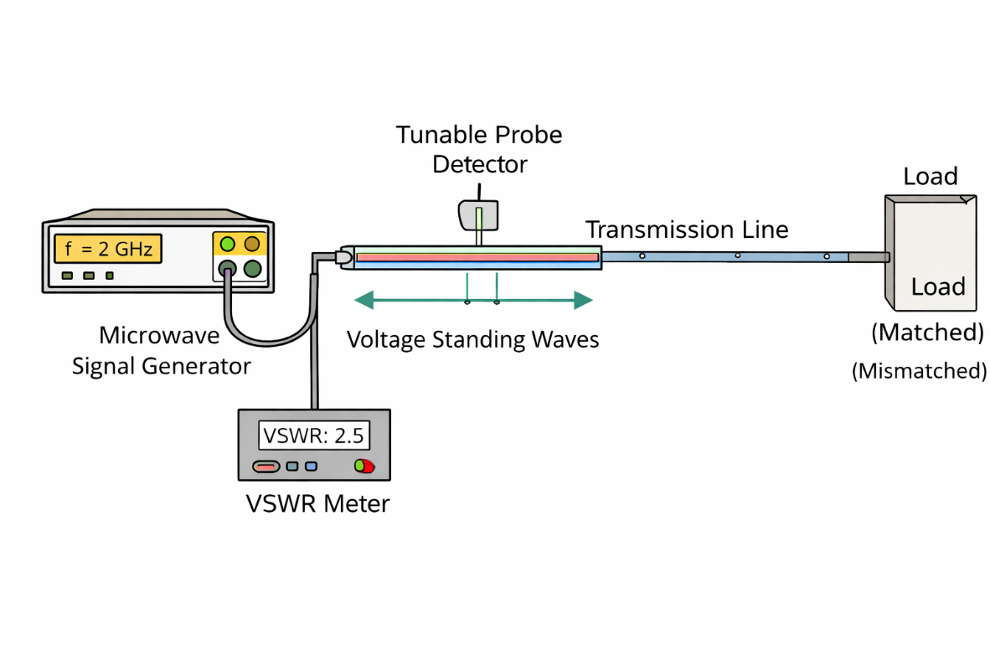EXPERIMENTS
The experiment on standing waves and Voltage Standing Wave Ratio (VSWR) is conducted to understand how electromagnetic waves behave in a transmission line when there is an impedance mismatch between the load and the transmission line. This experiment is fundamental in the study of microwave engineering, communication systems, and antenna design, where efficient transmission of signals is critical.
When a high-frequency signal is generated using a microwave signal generator and transmitted through a transmission line, it ideally travels toward the load without any loss. However, in practical conditions, if the load impedance (ZL) is not equal to the characteristic impedance (Z0) of the transmission line, part of the signal is reflected back toward the source. This reflected wave combines with the incident wave traveling forward, leading to the formation of standing waves.
Standing waves are characterized by a pattern of voltage variation along the transmission line. At certain points, the voltage reaches a maximum value, known as antinodes, while at other points, it reaches a minimum value, known as nodes. These points are stationary, meaning they do not move along the line, which is why the pattern is referred to as a “standing” wave.
In this experiment, a slotted line section is used to observe and measure the standing wave pattern. The slotted line has a narrow slot along its length, allowing a probe to be inserted. This probe is connected to a detector and a VSWR meter, which helps in measuring the voltage at different points along the transmission line.
The probe is carefully moved along the length of the slotted line. As it moves, the voltage level detected by the probe changes due to the standing wave pattern. By observing the readings on the VSWR meter, the positions of maximum voltage (Vmax) and minimum voltage (Vmin) are identified. These values are essential for calculating the VSWR.
The Voltage Standing Wave Ratio (VSWR) is defined as the ratio of the maximum voltage to the minimum voltage in a standing wave pattern. It is given by the formula:
VSWR = Vmax / Vmin
This ratio provides a measure of how well the load is matched to the transmission line. If the load is perfectly matched (ZL = Z0), there is no reflection, and the voltage remains constant along the line. In this case, Vmax equals Vmin, and the VSWR is equal to 1. This represents ideal conditions with maximum power transfer and no losses due to reflection.
However, when there is a mismatch, reflections occur, leading to variations in voltage. As the mismatch increases, the difference between Vmax and Vmin becomes larger, resulting in a higher VSWR. A high VSWR indicates poor matching and inefficient transmission, as a significant portion of the signal is reflected back toward the source instead of being absorbed by the load.
Another important parameter related to VSWR is the reflection coefficient (Γ), which represents the ratio of the reflected wave amplitude to the incident wave amplitude. The reflection coefficient depends on the difference between the load impedance and the characteristic impedance of the transmission line. As the mismatch increases, the reflection coefficient also increases, leading to a higher VSWR.
During the experiment, different load conditions are applied to observe how the standing wave pattern changes. For a matched load, the voltage remains almost constant along the transmission line, and no distinct nodes or antinodes are observed. In contrast, for mismatched loads, a clear standing wave pattern is visible, with periodic peaks and troughs in voltage.
The distance between two consecutive nodes or two consecutive antinodes is equal to half the wavelength (λ/2) of the signal. By measuring this distance, the wavelength of the signal can be determined. This provides additional insight into the behavior of electromagnetic waves in the transmission line.
The graphs obtained during the experiment further illustrate these concepts. The voltage versus distance graph shows a sinusoidal pattern, representing the standing wave. The VSWR versus load impedance graph demonstrates that the VSWR is minimum at the matched impedance and increases as the load deviates from this value. Similarly, the VSWR versus reflection coefficient graph shows a nonlinear relationship, where the VSWR increases rapidly as the reflection coefficient approaches unity.
This experiment also highlights practical challenges encountered in real-world systems. Factors such as connector losses, imperfect components, external interference, and measurement errors can affect the accuracy of the results. Care must be taken to minimize these errors by ensuring proper connections, stable signal generation, and careful handling of the probe.
Keep your text and graphic files separate until after the text has been formatted and styled. Do not use hard tabs, and limit use of hard returns to only one return at the end of a paragraph. Do not add any kind of pagination anywhere in the paper. Do not number text heads-the template will do that for you.

RESULTS
The experiment successfully demonstrated the formation of standing waves due to impedance mismatch. The VSWR was calculated for different load conditions, and it was observed that VSWR increases as the mismatch increases.
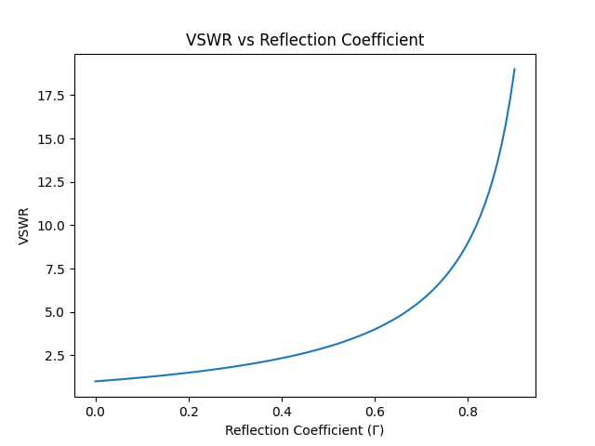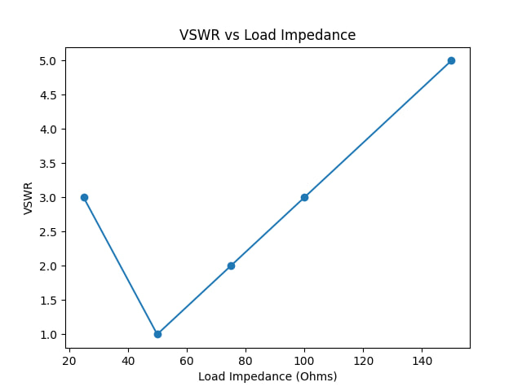

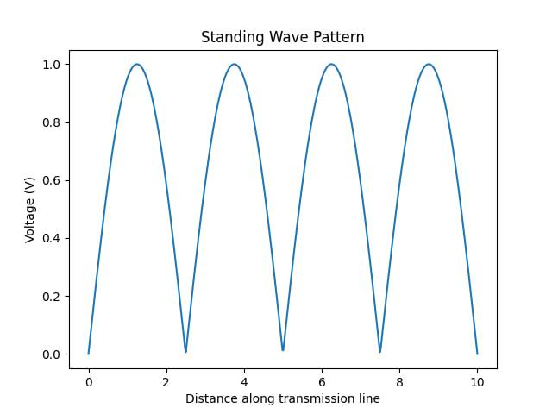

CONCLUSION and FUTURE WORK

The project successfully demonstrated the formation of standing waves in a transmission line due to impedance mismatch. The relationship between maximum and minimum voltages was used to calculate VSWR, which indicates the efficiency of power transmission. It was observed that higher impedance mismatch leads to higher VSWR, resulting in increased signal reflection and reduced efficiency. The experiment highlights the importance of proper impedance matching in communication systems. Understanding VSWR and standing waves is essential for designing efficient transmission lines, antennas, and RF systems.

References
• D. M. Pozar, Microwave Engineering, 4th ed., Hoboken, NJ, USA: John Wiley & Sons, 2012.
• G. Kennedy and B. Davis, Electronic Communication Systems, 5th ed., New Delhi, India: Tata McGraw-Hill, 2011.
• Simon Ramo, John R. Whinnery, and Theodore Van Duzer, Fields and Waves in Communication Electronics, 3rd ed., New York, USA: Wiley, 1994.
• A. Anand Kumar, Transmission Lines and Waveguides, 2nd ed., New Delhi, India: PHI Learning, 2009.
• “Transmission Line and VSWR,” NPTEL Online Course, IIT Kharagpur.
• “Standing Waves and VSWR,” Electronics Tutorials. [Online]. Available: https://www.electronics-tutorials.ws/
• IEEE Standard Definitions of Terms for Antennas, IEEE Std 145-2013.

